Experiment 25:
Aim:
25.Write a Python program to plot two or more lines with legends, different widths and colors.
Python code:
import matplotlib.pyplot as plt

# Data for the lines
x = [1, 2, 3, 4, 5, 6, 7]
y1 = [2, 4, 5, 7, 6, 8, 9]
y2 = [1, 3, 4, 5, 4, 6, 7]
y3 = [3, 5, 6, 8, 7, 9, 10]

# Plot multiple lines with different widths and colors
plt.plot(x, y1, color='blue', linewidth=1.5, label='Line 1')
plt.plot(x, y2, color='red', linewidth=2.5, label='Line 2')
plt.plot(x, y3, color='green', linewidth=3.5, label='Line 3')

# Add labels, title and legend
plt.xlabel('X-axis Label')
plt.ylabel('Y-axis Label')
plt.title('Multiple Lines with Legends, Widths and Colors')
plt.legend()

plt.show()
Output:
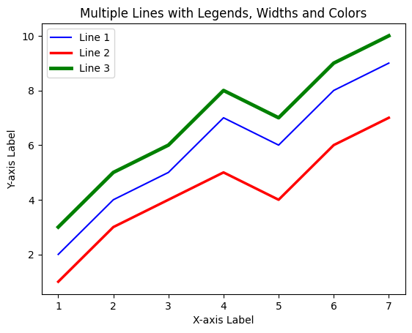
Experiment 26:
Aim:
26.Write a Python program to create multiple plots.
Python code:
import matplotlib.pyplot as plt

# Data for the plots
x = [1, 2, 3, 4, 5]
y1 = [1, 4, 9, 16, 25]
y2 = [1, 2, 3, 4, 5]
y3 = [25, 16, 9, 4, 1]
y4 = [5, 4, 3, 2, 1]

# Create multiple plots (2x2 grid)
fig, axs = plt.subplots(2, 2, figsize=(8, 6))

axs[0, 0].plot(x, y1, color='blue')
axs[0, 0].set_title('Plot 1: Square Numbers')

axs[0, 1].plot(x, y2, color='green')
axs[0, 1].set_title('Plot 2: Linear Increase')

axs[1, 0].plot(x, y3, color='red')
axs[1, 0].set_title('Plot 3: Square Decrease')

axs[1, 1].plot(x, y4, color='purple')
axs[1, 1].set_title('Plot 4: Linear Decrease')

plt.tight_layout()
plt.show()
Output:
